|  |  |
| --- | --- |
| Date | 14 October 2022 |
| Team ID | PNT2022TMID52122 |
| Project Name | Virtual Eye – Life Guard For Swimming Pools To Detect Active Drowning |
| Maximum Marks | 2 Marks |

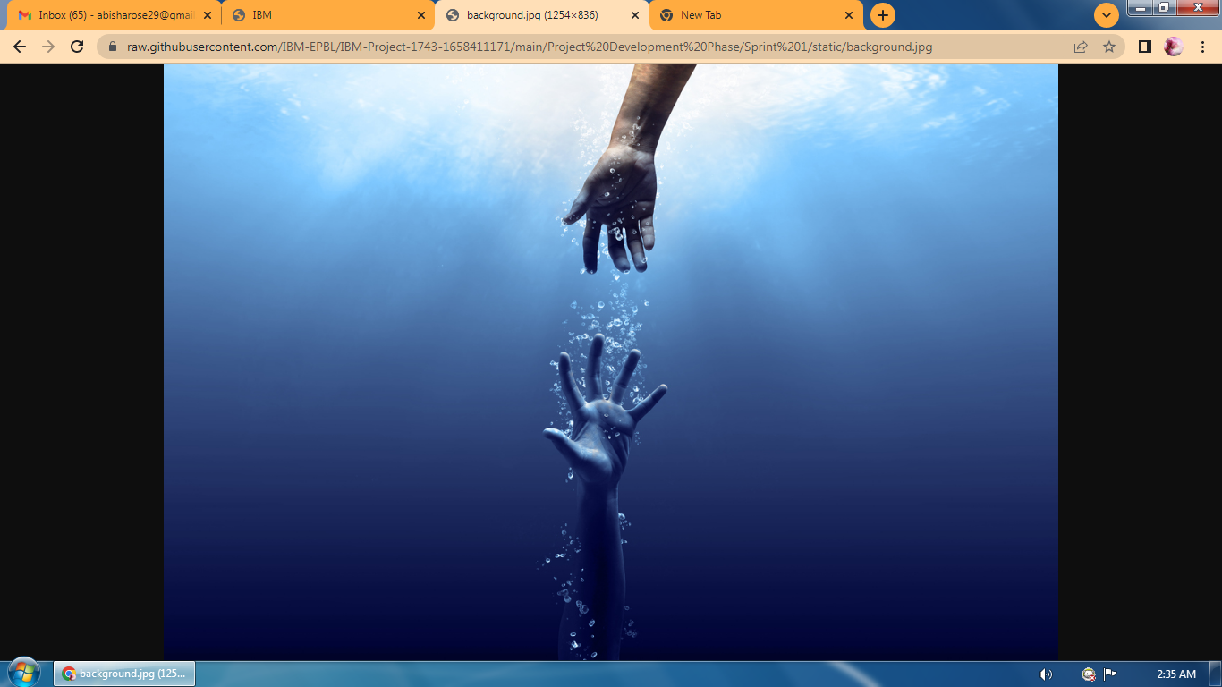



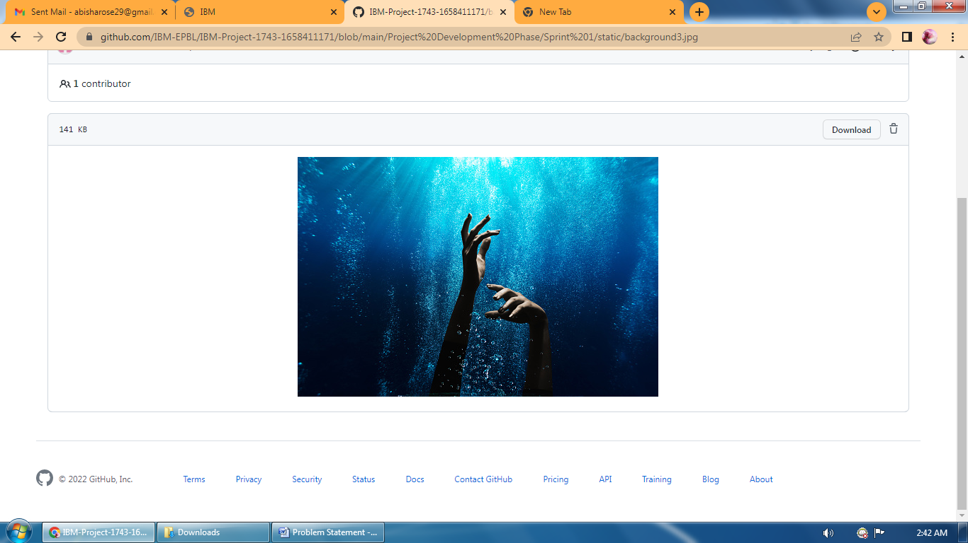

0 lines (0 sloc)  1 Byte